Akoonah Project

Introduction
In the Star Trek universe, an akoonah was a device used by some Native Americans in the 24th century to facilitate vision quests, taking the place of psychoactive herbs used by their ancestors. It was used by placing one's hand on the surface of the device and concentrating on an object important to the user.
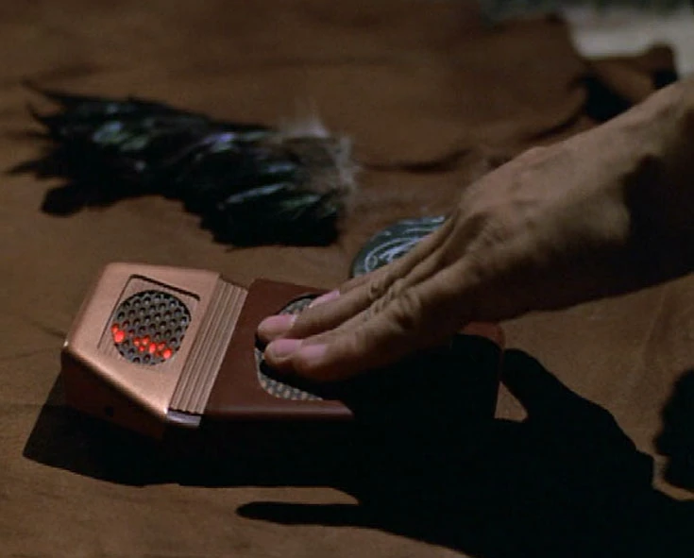
Commander Chakotay's medicine bundle consisted of a blackbird's wing, a river stone bearing a CHAH-mooz-ee, and an akoonah. In 2371, he showed Captain Kathryn Janeway how to use the akoonah so that she could seek her animal guide.
This guide (mostly generated by ChatGPT) provides instructions for building a small music-playing device using a Raspberry Pi Zero, non-rechargeable AA batteries, and a single button interface. The device will play music automatically when turned on.

Shopping List
- Raspberry Pi Zero W
  - Raspberry Pi Zero W with built-in Wi-Fi.
- MicroSD Card
  - 8GB or larger, pre-loaded with Raspberry Pi OS (Raspberry Pi OS Lite recommended).
- Battery Pack
  - 2x AA battery holder (with on/off switch).
  - 2x AA non-rechargeable batteries.
- Power Supply
  - A 5V power boost converter to step up the voltage from the AA batteries to 5V required by the Raspberry Pi.
- Buttons
  - 1x external power button (to turn the device on).
  - 1x internal button (to control Wi-Fi and trigger music playback).
- Speaker
  - Small speaker that can be connected to the Raspberry Pi's audio out or using a USB sound card.
- Wires and Connectors
  - Jumper wires and GPIO header pins to connect the buttons to the Raspberry Pi.
- Miscellaneous
  - Small enclosure to house the Raspberry Pi and components.

Assembly Instructions
- Setting Up the Raspberry Pi:
  - Install Raspberry Pi OS Lite on the MicroSD card.
  - Insert the MicroSD card into the Raspberry Pi Zero W.
  - Connect the Raspberry Pi to a monitor, keyboard, and mouse for initial setup (if required).
- Connecting the Power:
  - Connect the AA battery holder's leads to the input of the 5V power boost converter.
  - Connect the output of the boost converter to the 5V and GND pins on the Raspberry Pi Zero.
  - Use the external power button to control the power to the Raspberry Pi. The button should be wired to the positive terminal of the battery holder to directly control power to the Raspberry Pi.
- Setting Up the Buttons:
  - Connect the external power button to the 5V pin on the Raspberry Pi and any GPIO pin (e.g., GPIO17) to control the on/off functionality. Ensure the button is connected to ground via a pull-down resistor.
  - Connect the internal button to another GPIO pin (e.g., GPIO18) for Wi-Fi control. This button will manage the Wi-Fi functionality and trigger music playback.
- Connecting the Speaker:
  - If using the Raspberry Pi's built-in audio, connect the speaker to the Pi's audio out jack (if available).
  - If using a USB sound card, plug the sound card into one of the USB ports and connect the speaker to it.
- Enclosure:
  - Place the Raspberry Pi and components inside a small, protective enclosure. Ensure that the external button is accessible and the internal button is hidden to prevent accidental use.

Programming Access
- Accessing the Raspberry Pi:
  - If you're programming directly on the Raspberry Pi, use a monitor and keyboard attached to it, or you can access the Pi via SSH after enabling Wi-Fi (using the internal button).
- Installing Dependencies:
  - Install any necessary Python libraries (such as RPi.GPIO and subprocess) via the terminal:
sudo apt-get update
sudo apt-get install python3-rpi.gpio mpg123

Notes
- Power Management:
  - The power button directly controls the battery input to the Raspberry Pi, ensuring that it powers on as soon as the battery is connected. The internal button manages Wi-Fi control and music playback.
- Wi-Fi Management:
  - The Wi-Fi interface is controlled by the internal button using the rfkill tool. When the internal button is pressed, the Wi-Fi is enabled, and when released, it is disabled.
- Music Playback:
  - Music is played synchronously using mpg123. The Python script waits for each MP3 file to finish before moving on to the next one.
- SSH Access:
  - When the internal button is pressed, Wi-Fi is enabled, and the SSH daemon (sshd) is started, allowing remote access to the Raspberry Pi.
- GPIO Event Handling:
  - The internal button is monitored using GPIO event detection, so the script does not need to poll the button's state continuously. The button presses are detected and handled as events.

The Python script
import time
import subprocess
import random
import RPi.GPIO as GPIO
# GPIO Pin Setup
INTERNAL_BUTTON_PIN = 18 # Internal Button for Wi-Fi control
# MP3 Files
mp3_files = [
'/path/to/a.mp3',
'/path/to/b.mp3',
'/path/to/c.mp3'
]
# Initialize GPIO
GPIO.setmode(GPIO.BCM)
GPIO.setup(INTERNAL_BUTTON_PIN, GPIO.IN, pull_up_down=GPIO.PUD_UP)
# Functions for Wi-Fi control
def disable_wifi():
"""Disable Wi-Fi using rfkill"""
print("Disabling Wi-Fi...")
subprocess.run(['rfkill', 'block', 'wifi'])
def enable_wifi():
"""Enable Wi-Fi using rfkill"""
print("Enabling Wi-Fi...")
subprocess.run(['rfkill', 'unblock', 'wifi'])
# Functions to play music with mpg123 (synchronously)
def play_music():
"""Play music files in random order synchronously"""
random.shuffle(mp3_files)
for mp3 in mp3_files:
print(f"Playing {mp3}")
# This will block until the song finishes
subprocess.run(['mpg123', mp3])
# Functions to start SSH
def start_ssh():
print("Starting SSH...")
subprocess.run(['systemctl', 'start', 'sshd'])
# GPIO Event Handling
def button_callback(channel):
# Button OFF (Wi-Fi off)
if GPIO.input(INTERNAL_BUTTON_PIN) == GPIO.HIGH:
print("Wi-Fi is off, playing music...")
disable_wifi()
play_music()
else: # Button ON (Wi-Fi on)
print("Wi-Fi is on, starting SSHD...")
enable_wifi()
start_ssh()
def main():
"""Main loop to detect button presses without polling"""
# Add event detection for the internal button press with
# detect both button presses and releases
GPIO.add_event_detect(INTERNAL_BUTTON_PIN, GPIO.BOTH, bouncetime=300)
# Bind the event to the callback function
GPIO.add_event_callback(INTERNAL_BUTTON_PIN, button_callback)
# Keep the program running to detect button press events
try:
while True:
# Sleep and wait for button press events
time.sleep(1)
except KeyboardInterrupt:
GPIO.cleanup() # Cleanup GPIO on exit
if __name__ == '__main__':
main()

